SOP of DIA-NN v2.2.0 on HPC
Outline
Introduction
Summary of scripts
Procedure
1. Apply a computing node
2. Generate parameters and workflow of DIA-NN
3. Run the workflow of DIA-NN
4. Prepare JUMP Shiny input with DIA-NN output
5. Run JUMP Shiny
Appendix

Introduction
Amongst the data acquisition techniques employed in mass spectrometry, the two most popular ones are data-independent acquisition (DIA) and data-dependent acquisition (DDA). DIA is the superior method for analyzing complex proteomic samples due to its numerous advantages over DDA, including its ability to detect low-abundance peptides, its increased specificity, and its greater reproducibility. With its comprehensive and accurate analysis, DIA has become an indispensable tool for researchers in the fields of drug discovery and clinical research, helping to advance our understanding of complex biological systems and diseases. However, the data analysis of DIA is much more complex than DDA. DIA-NN and Spectronaut are the most popular DIA analysis tools. This SOP focuses on the operation procedure of DIA-NN and JUMP Shiny to generate the DIA report.

Summary of scripts
bsub -P DIANN -n 64 -q priority -R "rusage[mem=4G]" -R "span[hosts=1]" -Is bash
cd
mkdir DIATutorial_DIANN
cp -R /hpcf/authorized_apps/proteomics_apps/DIANN_CMD/CMD2 ./DIATutorial_DIANN
cd ./DIATutorial_DIANN/CMD2
# edit d_DIANNParamsOption.params
bash cmd_DIANNParams.sh
bash workflow.sh

Procedure
This part includes the operation procedure of DIA-NN and JUMP Shiny.

1. Apply a computing node
In your home path on the login node, e.g. [zyuan1@splprhpc12 ~]$, apply a computing node on HPC with the following command:
bsub -P DIANN -n 64 -q priority -R "rusage[mem=4G]" -R "span[hosts=1]" -Is bash
Note: It may take a long waiting time to get a computing node on a specific queue. You can try 4 queues: priority, standard, large_mem, large_core_count to check which is faster. Try this command to check the status for each queue:
qstat -l standard; qstat -l priority; qstat -l large_mem; qstat -l large_core_count

2. Generate parameters and workflow of DIA-NN
Here is the test data for the following procedure, which includes the data path, the fasta file, and commands to generate DIA-NN parameters and workflow as follows. (Note: The original data path and the result path can be different.)
/home/zyuan1/DIATutorial_DIANN2/data1
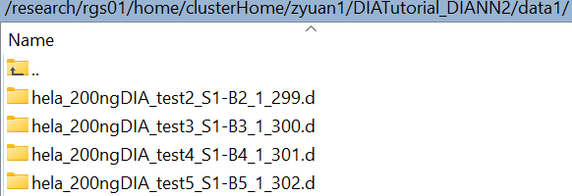
/home/zyuan1/DIATutorial_DIANN2/lib20241127/HUMAN
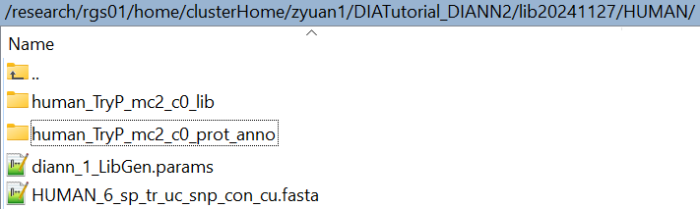
/hpcf/authorized_apps/proteomics_apps/DIANN_CMD/CMD2
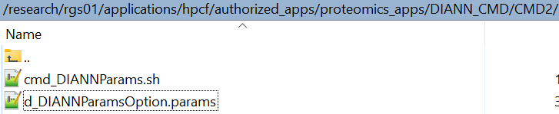

Here are the operation steps.
2.1. Copy commands to generate DIA-NN parameters from above path to your path (e.g. /home/zyuan1):
cd
mkdir DIATutorial_DIANN
cp -R /hpcf/authorized_apps/proteomics_apps/DIANN_CMD/CMD2 ./DIATutorial_DIANN
2.2. Open ‘d_DIANNParamsOption.params’ in your path, and change ‘data_path’, ‘fasta_file’ and other parameters to yours (e.g. additional_options = --var-mod Dimethyl,28.0313,KR is to search Dimethyl)
Note: these parameters are the same as the GUI parameters of DIANN v2.2.0. Change ‘d_DIANNParamsOption.params’, and other *.params files will be automatically changed (diann_1_LibGen.params, diann_2_Search.params, diann_3_iqQuan.params).

/home/zyuan1/DIATutorial_DIANN/CMD2
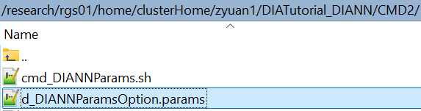
/home/zyuan1/DIATutorial_DIANN/CMD2/d_DIANNParamsOption.params
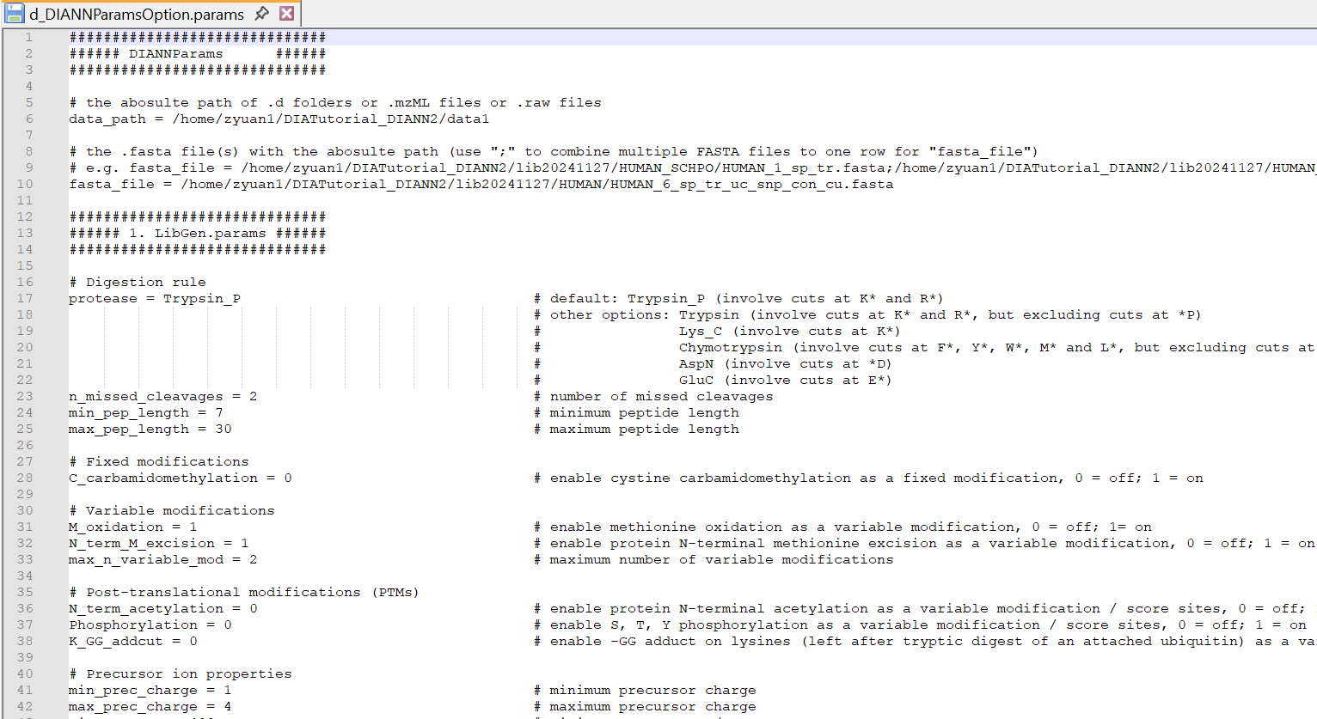
2.3. Run the following commands to generate DIA-NN parameters and workflow
cd
cd ./DIATutorial_DIANN/CMD2
bash cmd_DIANNParams.sh

/home/zyuan1/DIATutorial_DIANN/CMD2/cmd_DIANNParams.sh

Output of the command running (highlighted):
/home/zyuan1/DIATutorial_DIANN/CMD2
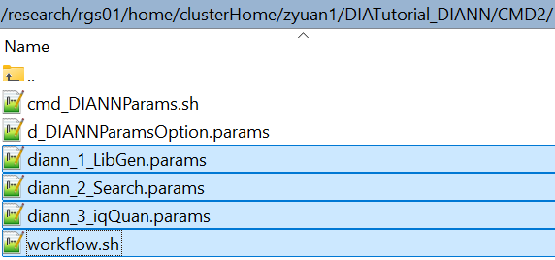

3. Run the workflow of DIA-NN
Running DIA-NN includes 3 steps: predicting the library, searching and quantifying precursors, quantifying proteins. If you change ‘d_DIANNParamsOption.params’ in step 2.2, and the 3 *.params files will be automatically changed: diann_1_LibGen.params, diann_2_Search.params, diann_3_iqQuan.params (Appendix A, B, C).

Run the following commands to run DIA-NN workflow with 3 steps: predicting the library, searching and quantifying precursors, quantifying proteins.
cd
cd ./DIATutorial_DIANN/CMD2
bash workflow.sh

/home/zyuan1/DIATutorial_DIANN/CMD2/workflow.sh
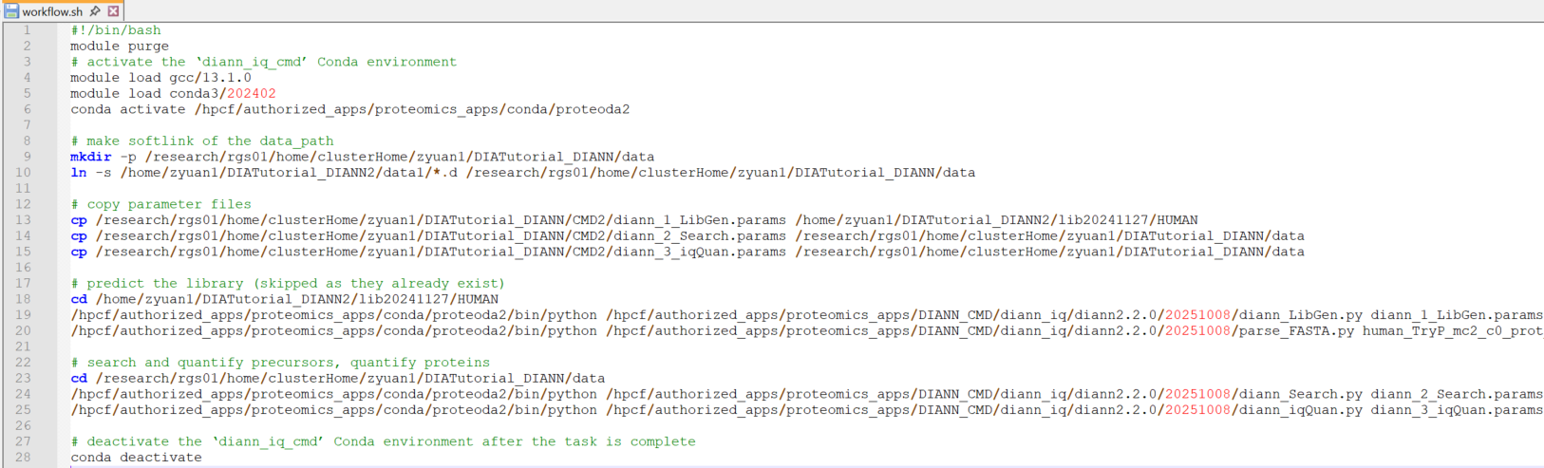

Note: If the library has been generated, in workflow.sh, the library generation step will be automatically skipped by commenting the corresponding commands.
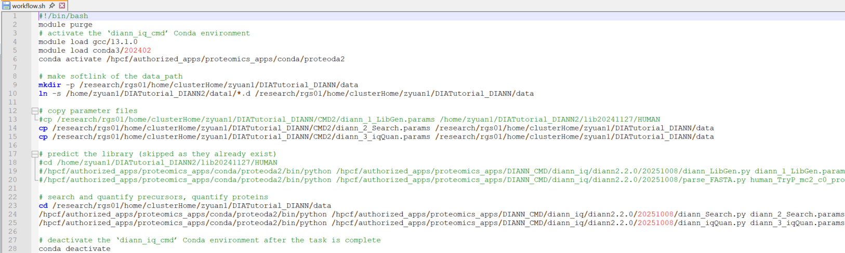

Output of the command running (highlighted):
/home/zyuan1/DIATutorial_DIANN2/lib20241127/HUMAN


/home/zyuan1/DIATutorial_DIANN2/lib20241127/HUMAN/human_TryP_mc2_c0_lib
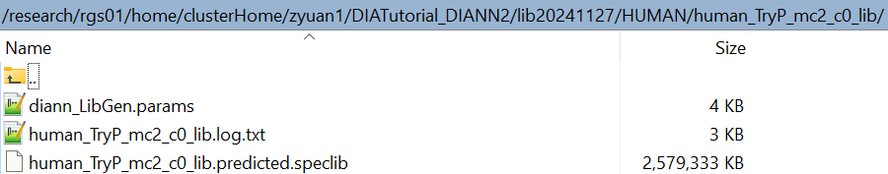

/home/zyuan1/DIATutorial_DIANN/data
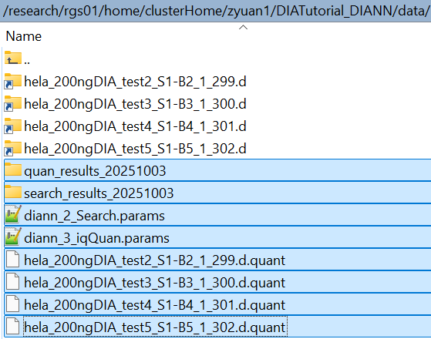

/home/zyuan1/DIATutorial_DIANN/data/search_results_20251003
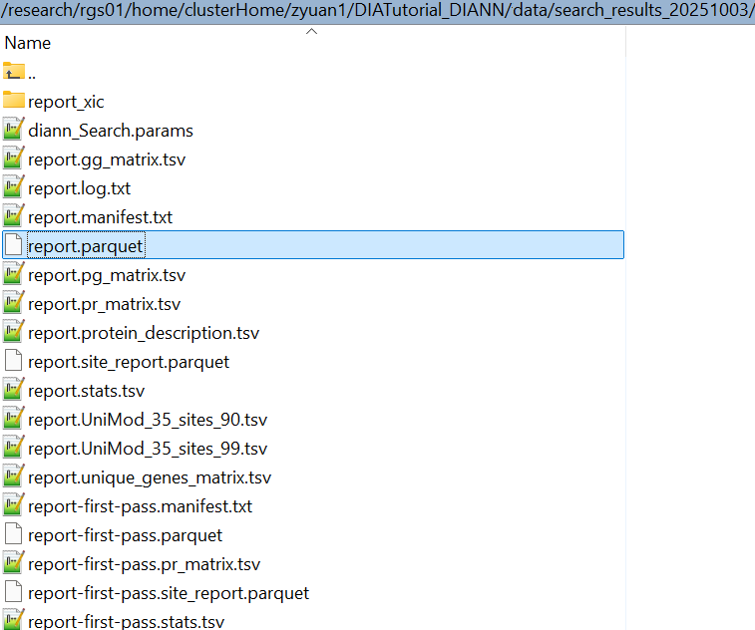

/home/zyuan1/DIATutorial_DIANN/data/quan_results_20251003/publication
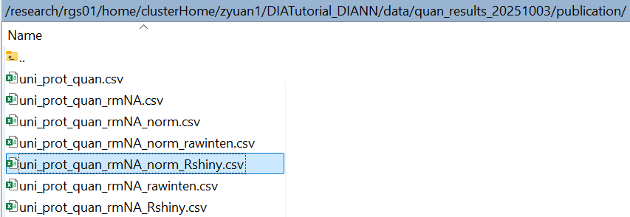

4. Prepare JUMP Shiny input with DIA-NN output
Because of the name issue (in JUMP Shiny, ‘_’ is acceptable, but ‘-’ is not; name starting with a number is not acceptable.), the above ‘uni_prot_quan_rmNA_norm_Rshiny.csv’ can be changed.

Here are the operation steps.
4.1. Download above ‘uni_prot_quan_rmNA_norm_Rshiny.csv’ from HPC to your PC.
4.2. Make the sample name shorter (e.g. ‘hela_200ngDIA_test5_S1_B5_1_302’ -> ‘hela_200ngDIA_test5’)
Original sample name
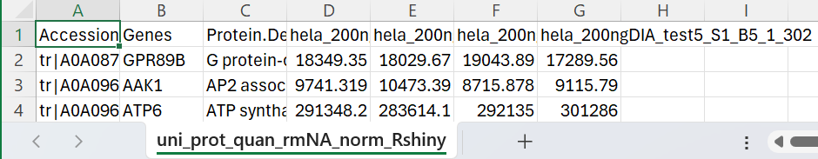

Shorter sample name
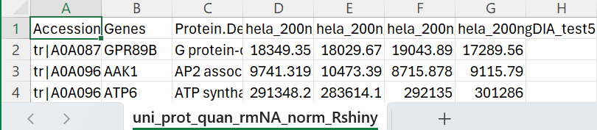

4.3. Prepare the ‘sample_info.xls’ file
First, create an empty .txt file ‘sample_info.txt’. Second, change it to ‘sample_info.xls’. Third, put the following information in ‘sample_info.xls’.
Sample Group
hela_200ngDIA_test2 Group1
hela_200ngDIA_test3 Group1
hela_200ngDIA_test4 Group2
hela_200ngDIA_test5 Group2
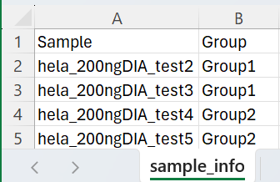

5. Run JUMP Shiny
In Web Browser (e.g. Chrome), input the URL: http://svlprshiny01.stjude.org/JUMPrshiny/
You can refer to the Tutorial tab in the left sidebar to learn how to do ‘Exploratory Analysis’ and ‘Differential Expression’. Here is a brief introduction to run JUMP Shiny.

5.1. Click on the Exploratory Analysis tab in the left sidebar
5.2. Upload data with ‘uni_prot_quan_rmNA_Rshiny.csv’, and upload sample information with ‘sample_info.xls’
5.3. Click on the ‘Assign group information’ button, and check ‘Intensity Distribution’ and ‘PCA’ for data quality
5.4. Click on the Differential Expression tab in the left sidebar
5.5. Click on the ‘Run Differential Expression Test’ button for pairwise comparison of Group1 and Group2, click on the ‘Download Result Table’ button to obtain the result table with p-value, FDR, Log2Fold for all proteins
DEresult.csv
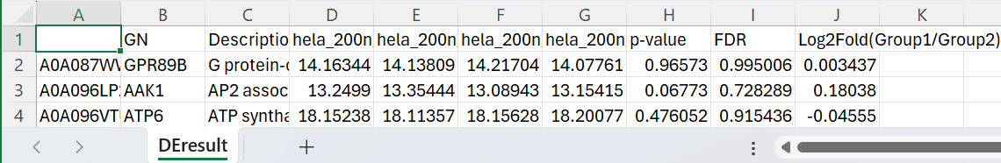
5.6. Click on the ‘SD within group’ page at the bottom, click on the ‘Calculate SD of Log2FC’ button for Group1 and Group2, and record 2SD as the Log2Fold cutoff (i.e. 0.5)
5.7. Click on the ‘Volcano Plot’ page, set p-value<0.05 and |Log2-fold|>0.5, click on the ‘Run Volcano Plot’ button to generate the volcano plot, click on the ‘Download DE Table’ button to obtain the DE table, open the DE table, sort by Log2Fold, put top 3 down-regulated protein IDs and top 3 up-regulated protein IDs in the box of ‘Interested protein to label on plot’ under ‘Advanced Parameters’, and the volcano plot with labels is ready to download.
Volcano Plot.svg
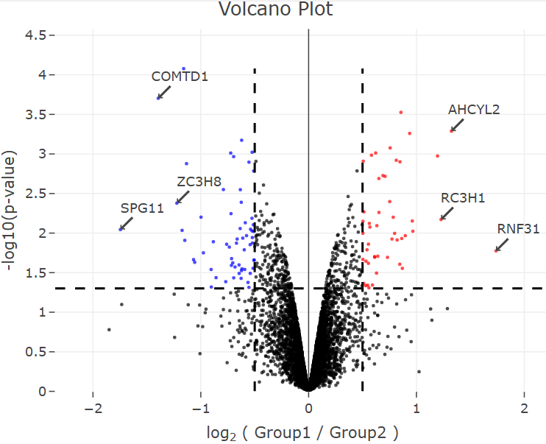

DEresult.csv and Volcano Plot.svg can be sent to users.

Appendix
Appendix shows the details to set DIA-NN parameters for 3 steps: predicting the library, searching and quantifying precursors, quantifying proteins. For more details of DIA-NN parameters, please refer to DIA-NN manual (https://github.com/vdemichev/diann).

d_DIANNParamsOption.params
Note: these parameters are the same as the GUI parameters of DIANN v2.2.0. Change ‘d_DIANNParamsOption.params’, and other *.params files will be automatically changed (diann_1_LibGen.params, diann_2_Search.params, diann_3_iqQuan.params).
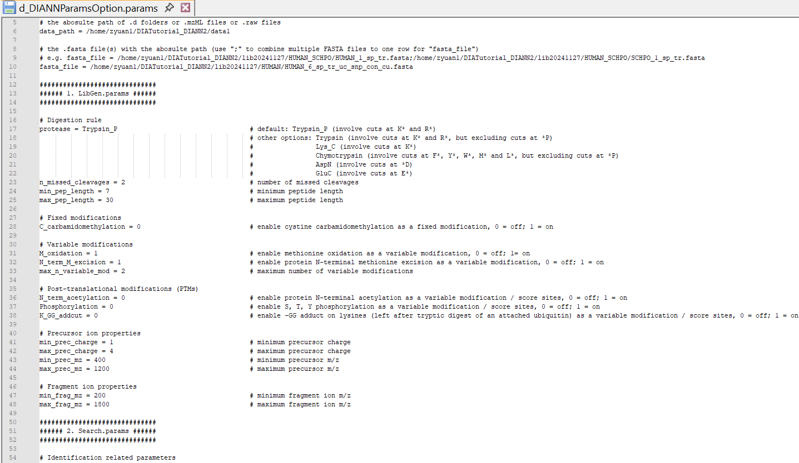
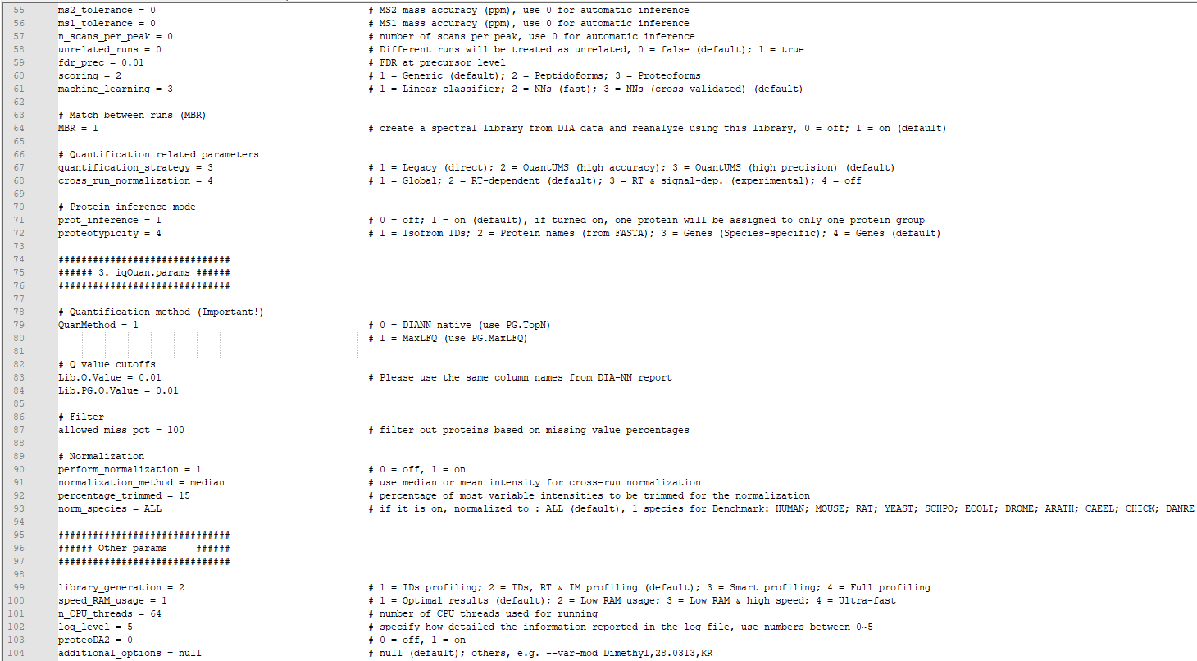

Appendix A. Predicting the library: in silico spectral library generation
This step will generate a predicted spectral library based on the input FASTA file. The predicted spectral library is in .speclib format (specific to DIA-NN software) and can be used for searching both Thermo Orbitrap (.mzML) and Bruker timsTOF (.d) MS data. Run this step when you want to build a customized library.
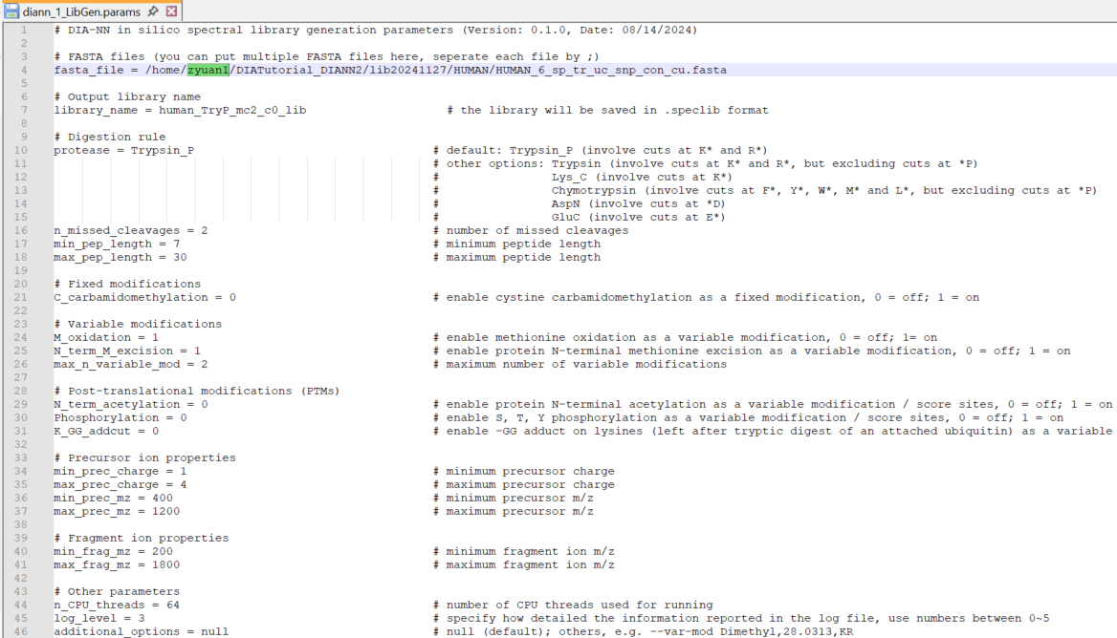

Change the ‘fasta_file’ and ‘library_name’ in the ‘diann_1_LibGen.params’ file and then run the following command:
python /hpcf/authorized_apps/proteomics_apps/DIANN_CMD/diann_iq/diann2.2.0/20251008/diann_LibGen.py diann_1_LibGen.params

Appendix B. Searching and quantifying precursors: library-based search
This step will search the MS data with the predicted spectral library.
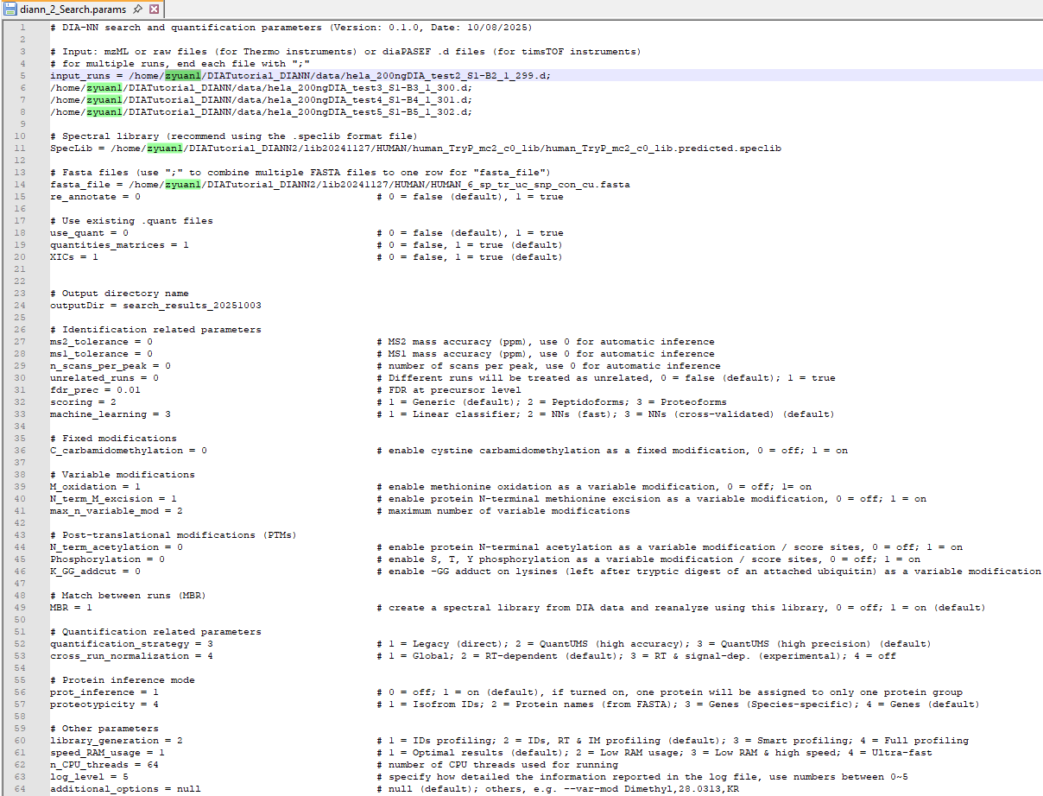
DIA-NN supports Bruker .d raw file. For Thermo data, please convert to .mzML file (see Appendix D for detail).
In the ‘diann_2_Search.params’ file, set the path for your raw files and spectral library and the name of output folder. Then run the following command:
python /hpcf/authorized_apps/proteomics_apps/DIANN_CMD/diann_iq/diann2.2.0/20251008/diann_Search.py diann_2_Search.params

Note: Some parameters should be the same as ‘diann_1_LibGen.params’ (e.g. Fixed/Variable modifications).

Appendix C. Quantifying proteins: protein quantification using DIANN native or MaxLFQ algorithm
After the second step, DIA-NN will output a ‘report.parquet’ file that can be used for further analysis. The ‘report.parquet’ file mainly contains the precursor-level identification and quantification information.

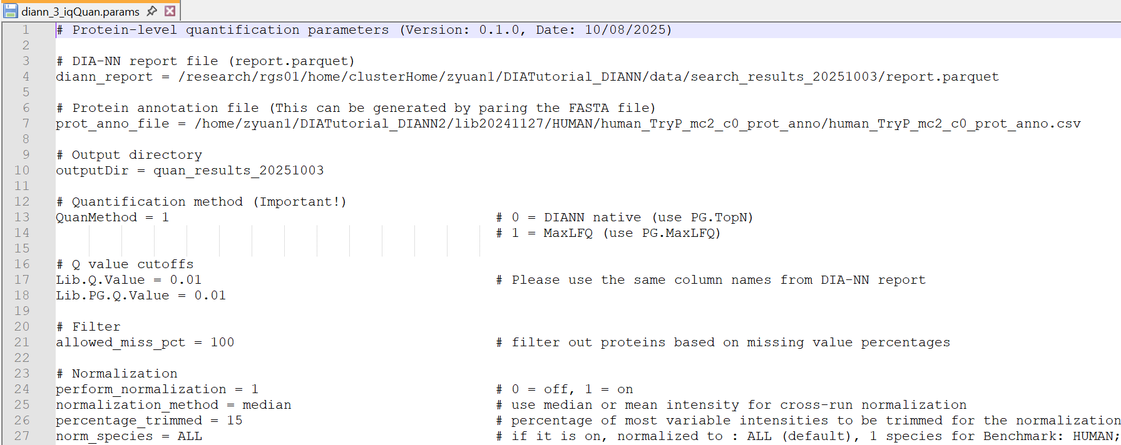
In the ‘diann_3_iqQuan.params’ file, set the path for the ‘report.parquet’ file and the name of output folder. You can also choose whether to perform the cross-run normalization. Command for this step:
python /hpcf/authorized_apps/proteomics_apps/DIANN_CMD/diann_iq/diann2.2.0/20251008/diann_iqQuan.py diann_3_iqQuan.params

Note: At this step you also need to input a ‘protein annotation file’ to add extra protein annotations in the final reports. The protein annotation file can be generated by parsing the FASTA file. Ideally, it should be the same file you used to generate the spectral library. If you use the pre-built libraries, you can use the annotation files that are already generated. If you used a customized FASTA file to build library, you need to generate the protein annotation file using the following command.
python /hpcf/authorized_apps/proteomics_apps/DIANN_CMD/diann_iq/diann2.2.0/20251008/parse_FASTA.py output_folder_name file1.fasta file2.fasta …

Appendix D. Thermo data conversion
MSConvertGUI is used for converting .raw file to mzML file. The software can be downloaded here (https://proteowizard.sourceforge.io/download.html).
DIA-NN requires using the following settings for the conversion.
